

CENTRE OF CAREER DEVELOPMENT

APPLICATION ORIENTED PROJECT REPORT OF

SKILL DEVELOPMENT TRAINING PROGRAMME (SDT)

# FOOD PARADISE

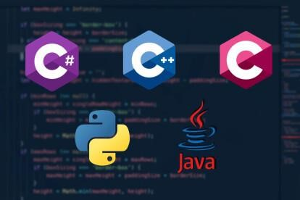

# SUBMITTED BY

Jennifer . E

Saranya. K

Desika. S

Harini prithika . R

Padaikathu. R

# IV Semester BE- CSE Students (Batch : 2023-2027)

# Department of Computer Science and Engineering

Adithya Institute of Technology

Coimbatore - 641107.



DEPARTMENT OF COMPUTER SCIENCE AND ENGINEERING

BONAFIDE CERTIFICATE

Certified that this project reports “ Food Paradise” are the bonafide work of “ JENNIFER (710123104029) , SARANYA(710123104053) , DESIKA(710123104012) , HARINI PRITHIKA (710123104024), PADAIKATHU (710123104043)” who carried out the project work under my supervision.

# SIGNATURE OF HOD SIGNATURE OF SUPERVISOR DR.VELMANI RAMASAMY, MRS.V.VANDHANA ,

# Professor &Head, Assitant Professor,

Department of CSE. Department of CSE.

Adithya Institute of Technology , Adithya Institute of Technology, Coimbatore – 641107. Coimbatore – 641107.

|  |  |  |
| --- | --- | --- |
|  | TITLE | PAGE NO |
| 1 | ABSTRACT |  |
| 2 | INTRODUCTION |  |
| 3 | PROJECT OBJECTIVE |  |
| 4 | MODULES |  |
| 5 | HARDWARE & SOFTWARE |  |
| 6 | PROGRAM |  |
| 7 | SAMPLE INPUT &OUTPUT |  |
| 8 | CONCLUSION |  |

TABLE OF CONTENTS

# ABSTRACT

The modern food blogging landscape is evolving into a dynamic platform that goes beyond recipes and restaurant reviews, embracing storytelling, cultural exploration, and sustainable food practices. As global interest in diverse cuisines, nutrition, and ethical food sourcing grows, food blogs serve as influential digital spaces that educate, inspire, and connect food enthusiasts, home cooks, and industry professionals.

This project explores how a food blog can act as more than just a collection of culinary content—it can be a medium for promoting sustainable eating habits, highlighting the importance of locally sourced ingredients, and preserving culinary traditions. By leveraging digital tools and social media, the blog aims to create an interactive space where readers can discover new flavors, learn about food history, and engage with the broader conversation on responsible food consumption.

The blog curates a wide range of content, from detailed recipes and cooking techniques to in-depth articles on food sustainability, nutrition, and cultural food heritage. It caters to a diverse audience, including amateur cooks seeking simple meal ideas, foodies exploring gourmet experiences, and individuals interested in ethical eating. A key focus is placed on making food accessible, whether through budget-friendly meal planning, dietary adaptations, or insights into global cuisines.

This project also addresses challenges within the food blogging industry, such as maintaining authenticity in an era of influencer marketing, navigating the impact of food trends, and ensuring credibility in nutritional information. Transparency is a core principle, with an emphasis on fact-based content, personal experiences, and expert contribution

In addition to recipe sharing, food blogs often address food trends, restaurant reviews, and health-conscious eating, contributing to broader cultural conversations about nutrition, sustainability, and the role of food in personal well-being. As a result, food blogs have become an integral part of the digital landscape, offering not just recipes but also a deeper connection to the world of food.

Through this platform, readers not only gain culinary knowledge but also join a global conversation about the transformative power of food in our everyday lives.

INTRODUCTION

Food is more than just sustenance—it is a reflection of culture, tradition, and personal identity. In the digital age, food blogs have emerged as powerful platforms that not only share recipes but also tell stories, explore culinary history, and promote sustainable and ethical food choices. As people become more conscious of what they eat, where it comes from, and how it impacts health and the environment, food blogs play a crucial role in shaping food trends and consumer awareness.

This project explores the potential of a food blog as a space for education, inspiration, and community engagement. Beyond being a collection of recipes, the blog serves as a digital hub where food enthusiasts can discover new flavors, learn about the origins of ingredients, and gain insights into healthy and mindful eating. Through visually appealing content, wellresearched articles, and interactive discussions, the blog seeks to create a holistic food experience for readers.

The growing interest in sustainability, farm-to-table movements, and dietary diversity makes it essential for food bloggers to provide reliable and responsible content. This blog is committed to highlighting ethical food practices, sharing accessible cooking techniques, and fostering an appreciation for the cultural significance of different cuisines.

Through this project, we aim to bridge the gap between food, culture, and responsible consumption, proving that a food blog can be both an entertaining and educational platform. By combining storytelling with practical guidance, the blog aspires to make cooking and food exploration an enjoyable and enriching journey for all.

# 

# PROJECT OBJECTIVES

1. Share Unique Recipes – Provide readers with easy-to-follow, well-researched, and creative recipes across different cuisines.

1. Promote Healthy Eating – Educate the audience on nutritious meal options, dietary tips, and balanced eating habits.

1. Explore Food Culture – Highlight the history, traditions, and regional influences of various dishes.

1. Restaurant and Product Reviews – Offer honest reviews of restaurants, food products, and culinary tools.

1. Encourage Community Engagement – Create a space for food enthusiasts to share experiences, tips, and personal stories.

1. Monetization and Growth – Develop strategies for content monetization, including affiliate marketing, sponsored content, and advertisements, to ensure long-term sustainability.

# 

MODULE

MODULE 1: Introduction to Food Blogging

Overview of food blogging and its evolution

The role of storytelling in food blogs

Understanding audience demographics and interests

Choosing a niche: Recipes, restaurant reviews, food sustainability, cultural food exploration, etc.

MODULE 2: Content Creation & Storytelling

Writing compelling and engaging food-related content

Importance of personal experiences and authenticity in food blogging

Structuring blog posts: Recipes, reviews, and food stories

Best practices for food photography and videography

MODULE 3: Recipe Development & Presentation

How to create and test recipes

Writing clear and easy-to-follow recipe instructions

The science behind flavors and ingredient pairing

Food styling and plating techniques for visual appeal

MODULE 4: Food Culture, Trends, and Ethics

Exploring global cuisines and food traditions

Understanding food trends and their impact

Ethical food sourcing: Farm-to-table, organic, and sustainable practices

Addressing dietary restrictions and inclusive cooking

MODULE 5: Nutrition and Healthy Eating

Basics of nutrition and balanced meals

Meal planning and budgeting for healthy eating

Debunking food myths and misinformation

Special diets: Vegan, keto, gluten-free, etc.

MODULE 6: Digital Marketing & Audience Engagement

Building an online presence through SEO and social media

Engaging with readers through comments, forums, and social media interactions

Collaborating with other food bloggers and brands

Monetization strategies: Ads, sponsorships, affiliate marketing, and e-books

MODULE 7: Food Photography & Visual Content Creation

Essential equipment for food photography

Lighting, angles, and composition techniques

Editing photos and videos for professional appeal

Using social media platforms (Instagram, Pinterest, TikTok) for visual storytelling

MODULE 8: Sustainability and Responsible Food Blogging

Promoting sustainable food practices through blog content

Addressing food waste and responsible consumption

Ethical considerations in food blogging (honest reviews, transparency, and inclusivity) Collaborating with sustainable food brands and organizations

MODULE 9: Website Management & Technical Aspects

Choosing the right platform (WordPress, Blogger, etc.)

Website design, layout, and user experience

Optimizing blog performance and site speed

Analytics and tracking audience engagement

MODULE 10: Future of Food Blogging & Innovation

Emerging technologies in food blogging (AI, AR food experiences, etc.)

The role of virtual and augmented reality in food exploration

HARDWARE AND SOFTWARE

Hardware specifications :

Device name : DESKTOP-P3ABR40

Processor : Intel(R) Core(TM) i5-8265U CPU @ 1.60GHz 1.80 GHz

RAM:8.00 GB (7.84 GB usable)

System type:64-bit operating system, x64-based processor

Software specifications:The project is developed using a combination of server-side and client-side technologies

Backend (Server-side)

Programming Language: Python(flask framework)

Framework: Flask (micro web framework)

Database: SQLite (lightweight database for storing user and product data)

Authentication: Flask-login (user authentication)

Password Hashing: Flask-Bcrypt (secure password storage)

Frontend (Client-side)

HTML: For structuring web pages

CSS: Custom styles for an eco-friendly look

Bootstrap: For responsive engine for dynamic content rendering

Development tools

IDE/Editor: VS code pycharm, or any text editor

Version Control: Git & GitHub (For source code management)

Virtual Environment: Python venv (To manage dependencies)

## PROGRAM

Program 1:

<!DOCTYPE html>

<html lang=”en”>

<head>

<meta charset=”UTF-8”>

<meta name=”viewport” content=”width=device-width, initial-scale=1.0”>

<meta http-equiv=”X-UA-Compatible” content=”ie=edge”>

<title>Foodie’s Paradise – Food Blog</title>

<link rel=”stylesheet” href=”./style.css”>

</head>

<body>

<header>

<div class=”logo”>

<h1>Foodie’s Paradise</h1>

</div>

<nav>

<ul>

<li><a href=”index.html”>Home</a></li>

<li><a href=”recipe.html”>Recipes</a></li>

<li><a href=”about.html”>About</a></li>

<li><a href=”contact.html”>Contact</a></li>

</ul>

</nav>

</header>

<section id=”home”>

<div class=”hero”>

<h2>Welcome to Foodie’s Paradise!</h2>

<img src=”640684_sld.jpg” alt=”Foodie’s Fantasy” style=”width: 500px; height:

auto;”>

<p>Your go-to blog for delicious recipes and food tips.</p>

</div>

</section>

<footer>

<p>&copy; 2025 Foodie’s Paradise. All Rights Reserved.</p>

<p><a href=[https://www.foodiesparadise.com>](https://www.foodiesparadise.com/)Click here to visit Foodie’s Paradise</a></p>

</footer>

</body>

</html

Program 2:

<!DOCTYPE html>

<html lang=”en”>

<head>

<meta charset=”UTF-5”>

<meta name=”viewport” content=”width=device-width, initial-scale=1.0”>

<meta http-equiv=”X-UA-Compatible” content=”ie=edge”>

<title>Foodie’s Paradise – Food Blog</title>

<link rel=”stylesheet” href=”./style.css”>

</head>

<body>

<header>

<div class=”logo”>

<h1>Foodie’s Paradise</h1>

</div>

<nav>

<ul>

<li><a href=”index.html”>Home</a></li>

<li><a href=”recipe.html”>Recipes</a></li>

<li><a href=”about.html”>About</a></li>

<li><a href=”contact.html”>Contact</a></li>

</ul>

</nav>

</header>

<section id=”about”>

<h2>About Me</h2>

<img src=”chef.png” alt=”” style=”height: 200px; width: 200px;”>

<p>Hi, I’m Jenni, the creator of Foodie’s Paradise. I’m passionate about cooking, and I love sharing my recipes

With others. My goal is to inspire home cooks to try new recipes and explore the wonderful world of food!

</p>

</section>

<footer>

<p>&copy; 2025 Foodie’s Paradise. All Rights Reserved.</p> </footer>

</body>

</html

SAMPLE OUTPUT

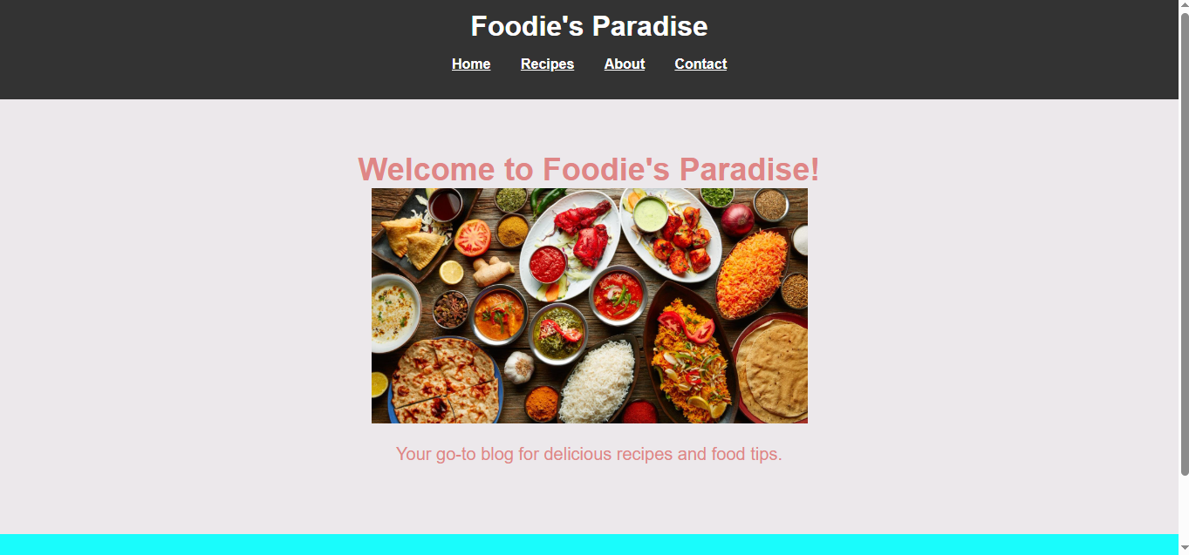

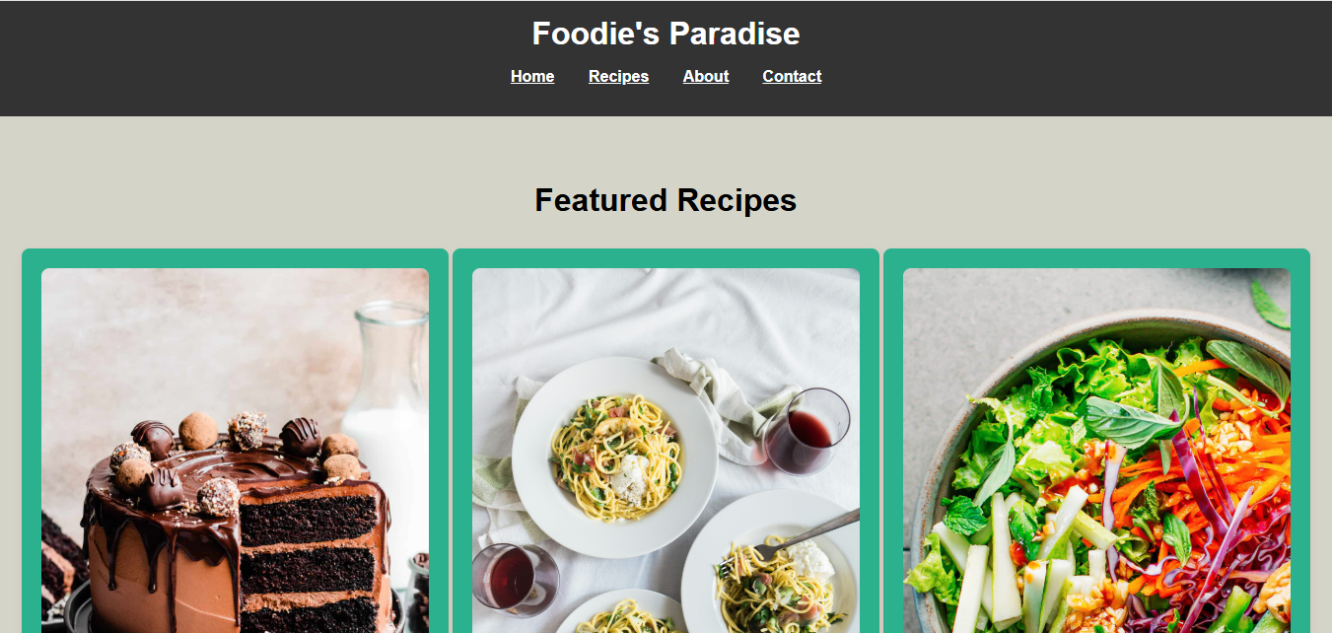

# 

# ­­­­­­

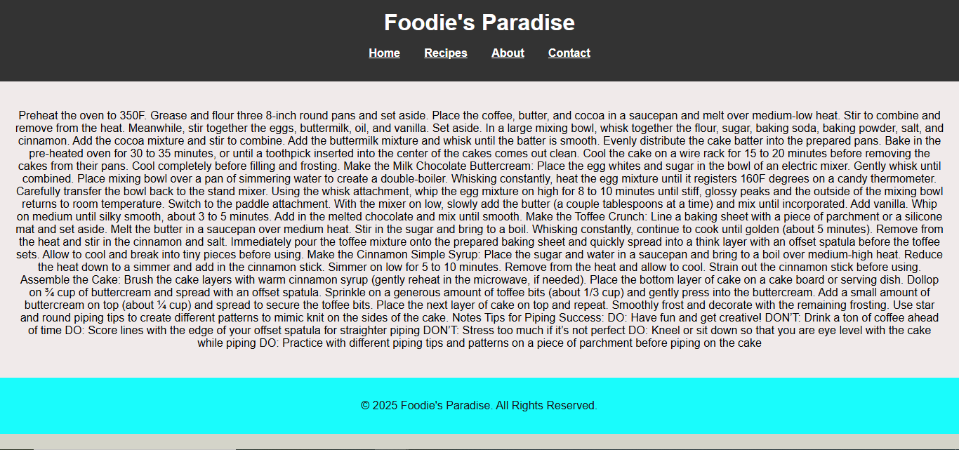

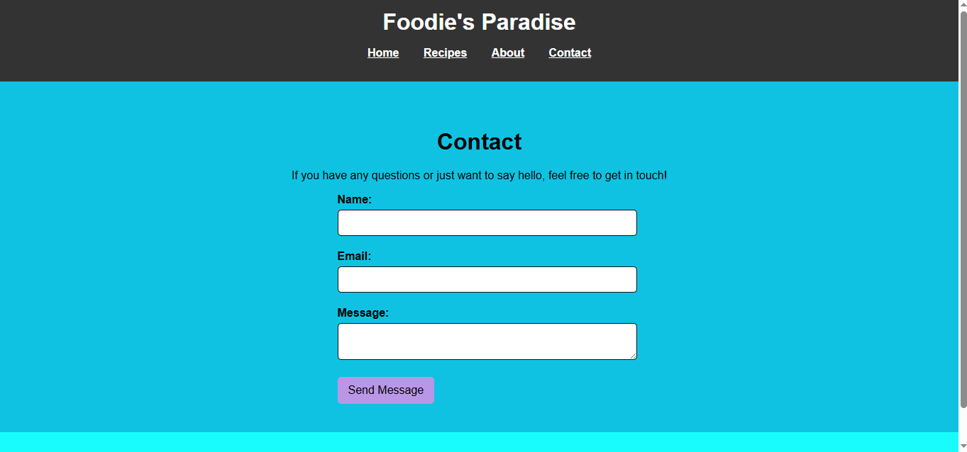

CONCLUSION

Food blogging is more than just sharing recipes—it is a dynamic platform that blends storytelling, culture, and education to create a meaningful food experience. As food choices increasingly reflect health consciousness, ethical considerations, and global influences, food blogs play a vital role in guiding and inspiring audiences.

This project highlights how a well-crafted food blog can serve as a bridge between tradition and innovation, offering readers valuable insights into diverse cuisines, sustainable eating practices, and mindful consumption. By combining engaging content, visually appealing presentations, and reliable information, food bloggers can foster a community that appreciates both the art and science of food.

Ultimately, a successful food blog goes beyond mere content creation; it cultivates a passion

for cooking, promotes responsible food habits, and encourages cultural appreciation. As the food landscape evolves, blogs have the potential to shape food trends, empower home cooks, and contribute to a more informed and connected culinary world.